1**Code:-**

**A)**

import pandas as pd

mtcars = pd.read_csv('prac1/mtcars.csv')

# Display basic information about the mtcars dataset

print("Summary for mtcars dataset:")

print(mtcars.info())

print("\n")

#Display summary statistics

print("Summary Statistics for mtcars dataset:")

print(mtcars.describe())

# Display structure information

print("\nStructure Information for mtcars dataset:")

print(mtcars.info())

#Display quartile information for numeric columns

numeric_columns = mtcars.select_dtypes(include=['number']).columns

print("\nQuartile Information for mtcars dataset:")

print(mtcars[numeric_columns].quantile([0.25, 0.5, 0.75]))

cars = pd.read_csv('prac1/cars.csv')

# Display basic information about the cars dataset

print("Summary for cars dataset:")

print(cars.info())

print("\n")

#Display summary statistics

print("Summary Statistics for cars dataset:")

print(cars.describe())

# Display structure information

print("\nStructure Information for cars dataset:")

print(cars.info())

#Display quartile information for numeric columns

numeric_columns = cars.select_dtypes(include=['number']).columns

print("\nQuartile Information for cars dataset:")

print(cars[numeric_columns].quantile([0.25, 0.5, 0.75]))

**b)**

import pandas as pd

# Load the Iris dataset from CSV file

iris_df = pd.read_csv('prac1/iris.csv')

# Display a subset of the dataset using subset() function

subset_condition = (iris_df['sepal.length'] > 5) & (iris_df['sepal.width'] > 3)

subset_result = iris_df[subset_condition]

print("Subset of the Iris dataset using subset() function:")

print(subset_result)

print("\n")

# Aggregate the dataset using aggregate() function

aggregation_result = iris_df.groupby('variety').aggregate({

'sepal.length': 'mean',

'sepal.width': 'std',

'petal.length': 'mean',

'petal.width': 'std'

})

aggregation_result.rename(columns={

'sepal.length': 'mean_sepal_length',

'sepal.width': 'std_sepal_width',

'petal.length': 'mean_petal_length',

'petal.width': 'std_petal_width'

}, inplace=True)

print("Aggregation of the Iris dataset using aggregate() function:")

print(aggregation_result)

1**Output:-**

**a)**

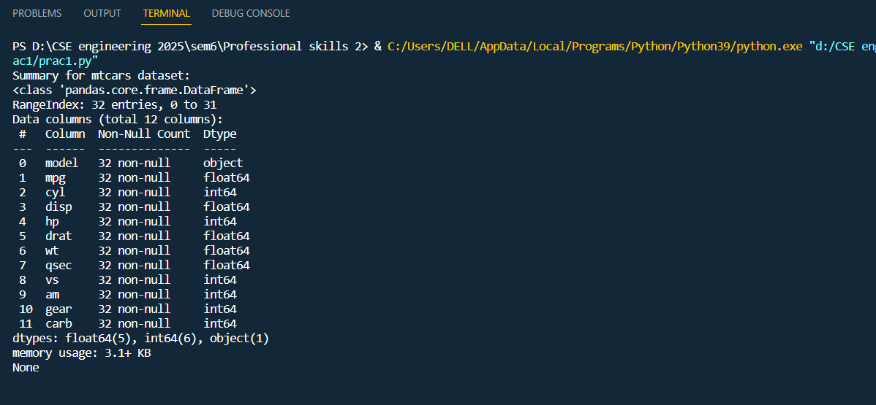

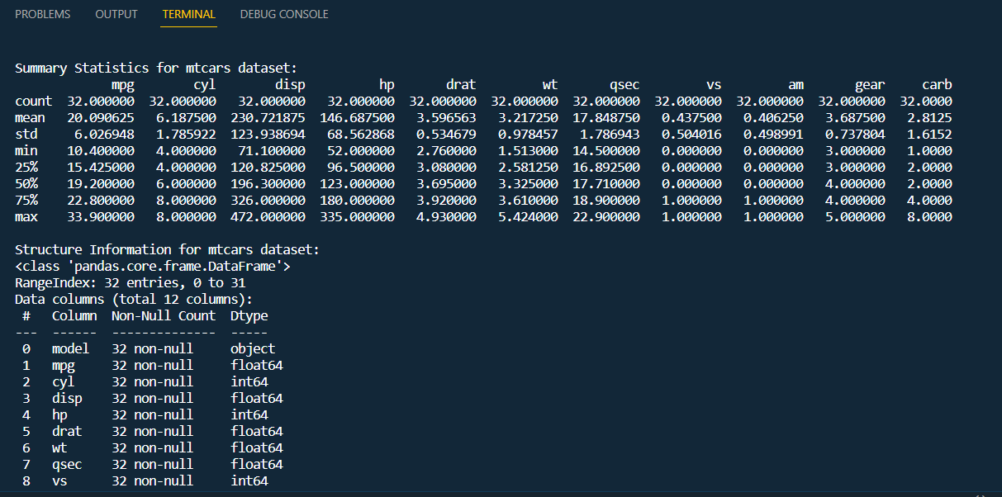

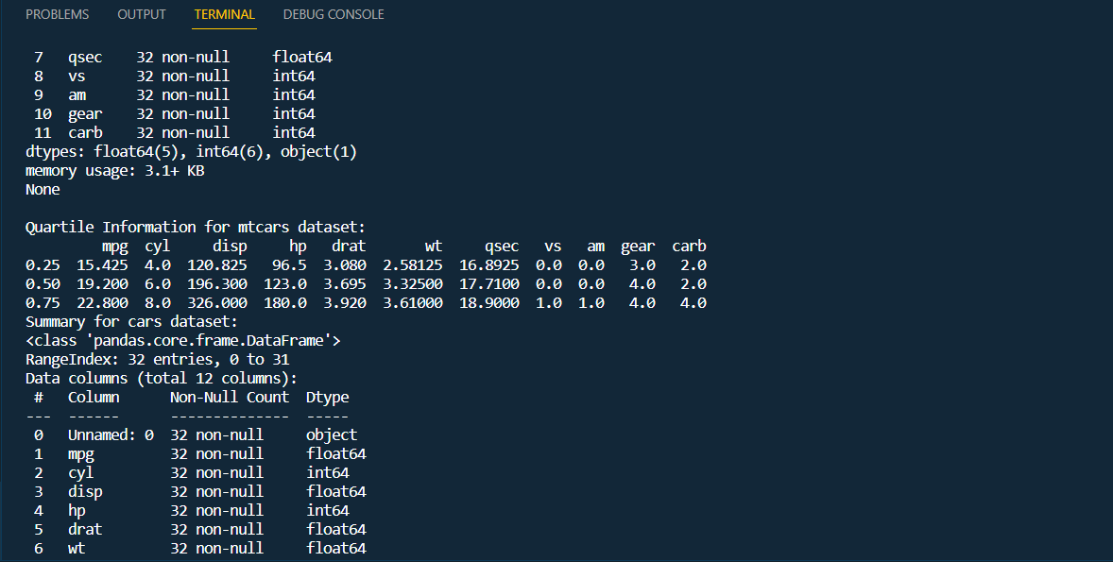

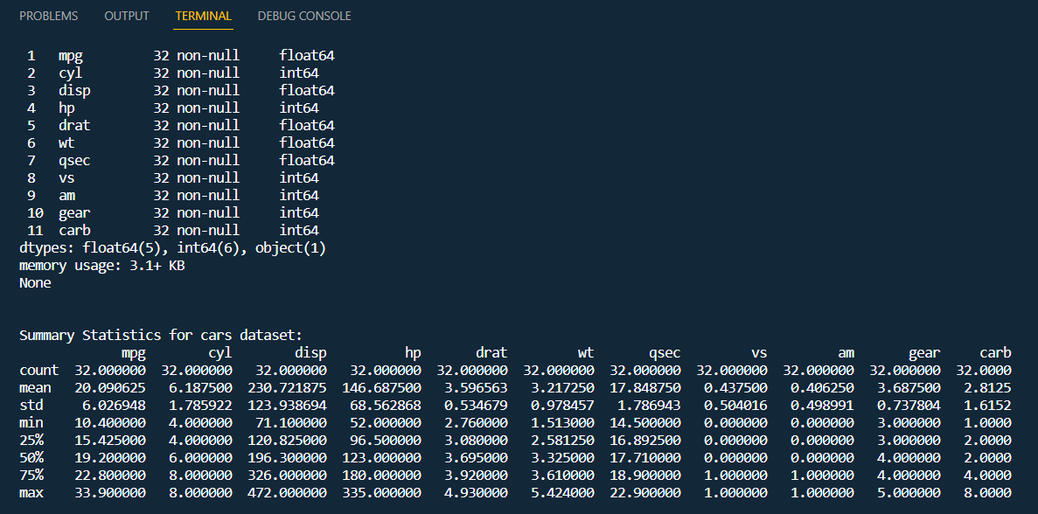

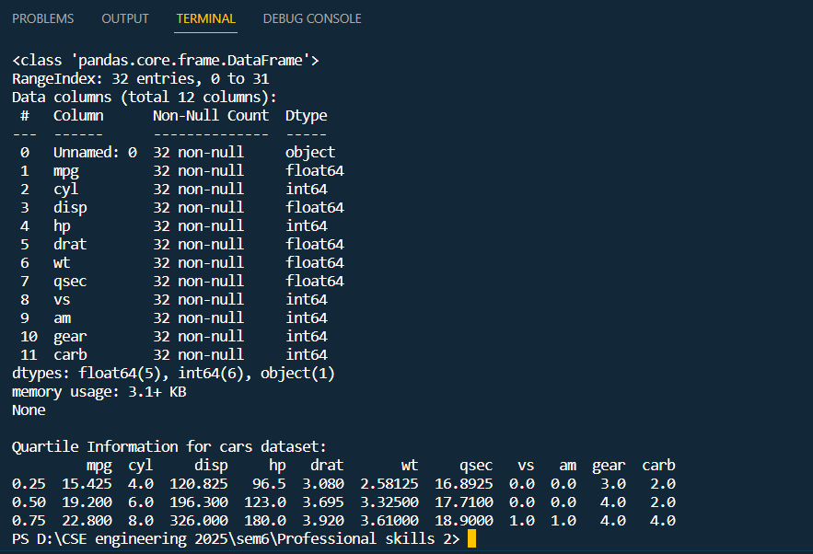

**b)**

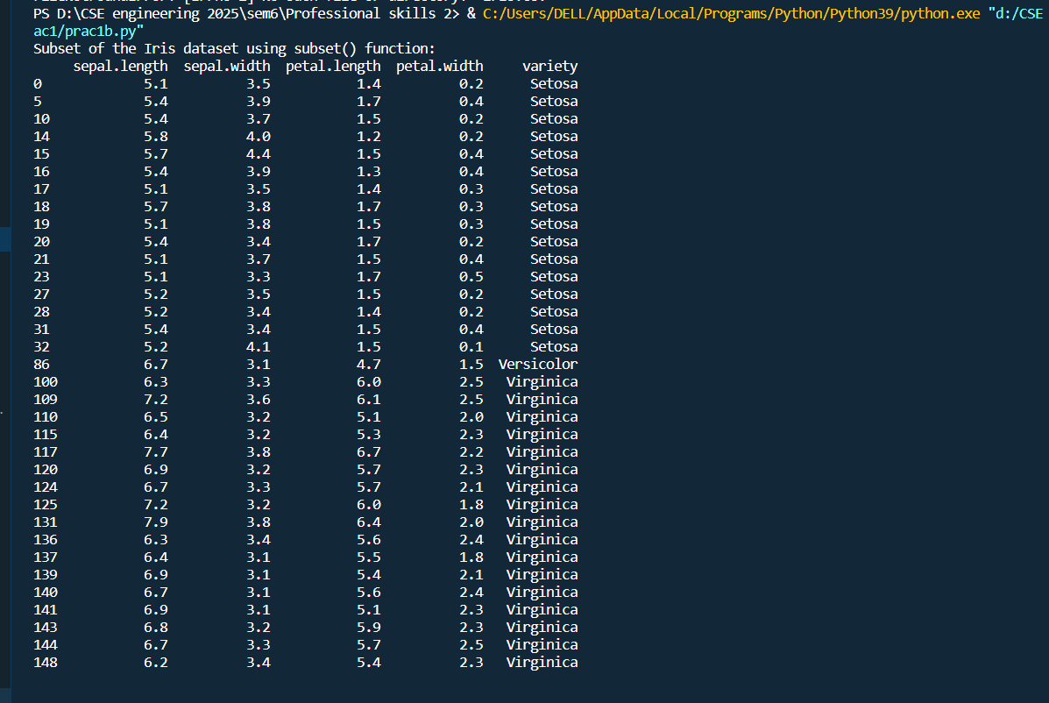

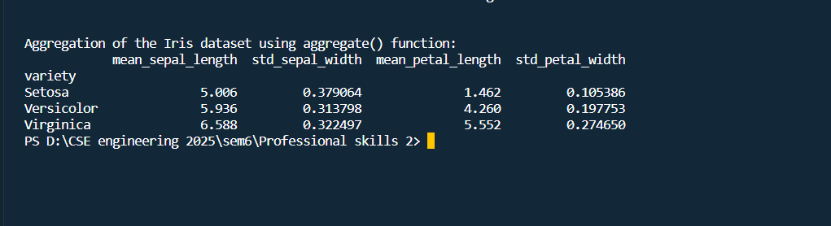

2**Code:-**

import pandas as pd

# Read a CSV file from the web

url_csv = 'https://gist.githubusercontent.com/rnirmal/e01acfdaf54a6f9b24e91ba4cae63518/raw/6b589a5c5a851711e20c5eb28f9d54742d1fe2dc/datasets.csv'

df_csv_web = pd.read_csv(url_csv)

# Read a TXT file from the web

url_txt = 'https://raw.githubusercontent.com/selva86/datasets/master/sample.txt'

df_txt_web = pd.read_csv(url_txt, delimiter='\t') # Assuming tab-separated data

# Read a CSV file from disk

file_csv_disk = 'prac2/iris.csv'

df_csv_disk = pd.read_csv(file_csv_disk)

# Read a TXT file from disk

file_txt_disk = 'prac2/sample.txt'

df_txt_disk = pd.read_csv(file_txt_disk, delimiter='\t') # Assuming tab-separated data

# Concatenate the dataframes

combined_df = pd.concat([df_csv_web, df_txt_web, df_csv_disk, df_txt_disk], ignore_index=True)

# Display the shape (number of rows and columns) of the combined dataframe

print("Shape of the combined dataframe:", combined_df.shape)

# Write the combined dataframe to a file on disk

output_file = 'prac2/combined_data.csv'

combined_df.to_csv(output_file, index=False)

print("Combined data has been written to:", output_file)

2**Output:-**

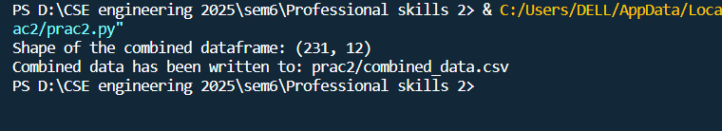

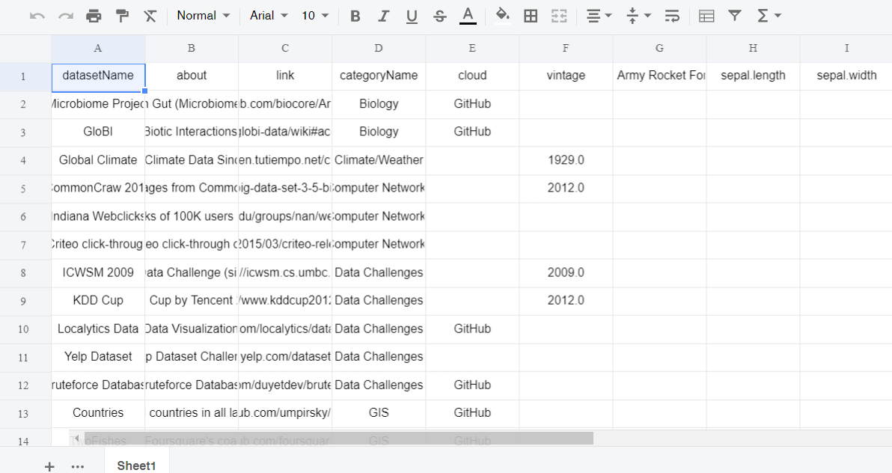

2**Code:-**

import pandas as pd

# Specify the path to your Excel file

excel_file_path = 'prac2/airline.xlsx'

# Read the Excel file into a DataFrame

df_excel = pd.read_excel(excel_file_path)

# Display the DataFrame

print(df_excel)

2**Output:-**

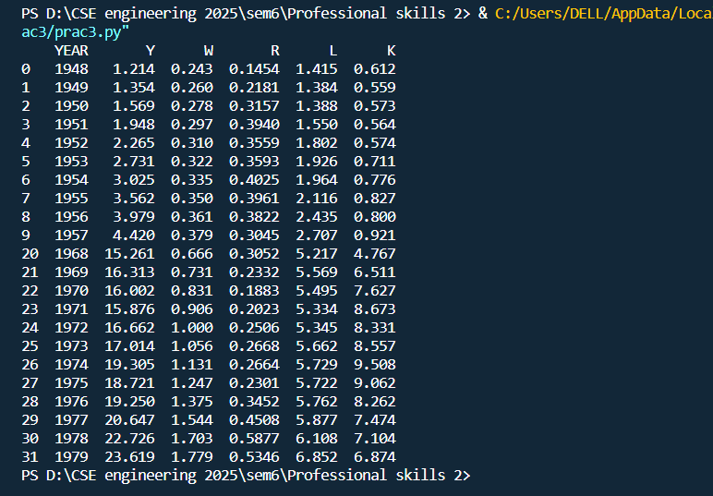

3**Code:-**

import pandas as pd

import matplotlib.pyplot as plt

import seaborn as sns

# Load the Iris dataset

iris_df = pd.read_csv("prac3/iris.csv")

# Display the first few rows of the dataset

print(iris_df.head())

# a. Box and scatter plots for data distributions

# Box plot

plt.figure(figsize=(10, 6))

sns.boxplot(data=iris_df)

plt.title("Box Plot of Iris Dataset")

plt.xlabel("Features")

plt.ylabel("Centimeters")

plt.xticks(rotation=45)

plt.show()

# Scatter plot

plt.figure(figsize=(10, 6))

sns.scatterplot(data=iris_df, x='sepal.length', y='sepal.width', hue='variety')

plt.title("Scatter Plot of Sepal Length vs Sepal Width")

plt.xlabel("Sepal Length (cm)")

plt.ylabel("Sepal Width (cm)")

plt.show()

# b. Finding outliers using box plot

plt.figure(figsize=(10, 6))

sns.boxplot(data=iris_df)

plt.title("Box Plot to Identify Outliers")

plt.xlabel("Features")

plt.ylabel("Centimeters")

plt.xticks(rotation=45)

plt.show()

# c. Histogram and pie chart

# Histogram

plt.figure(figsize=(10, 6))

plt.hist(iris_df['petal.length'], bins=20, edgecolor='black')

plt.title("Histogram of Petal Length")

plt.xlabel("Petal Length (cm)")

plt.ylabel("Frequency")

plt.show()

# Pie chart

variety_counts = iris_df['variety'].value_counts()

plt.figure(figsize=(8, 8))

plt.pie(variety_counts, labels=variety_counts.index, autopct='%1.1f%%', startangle=140)

plt.title("Distribution of Iris variety")

plt.axis('equal') # Equal aspect ratio ensures that pie is drawn as a circle.

plt.show()

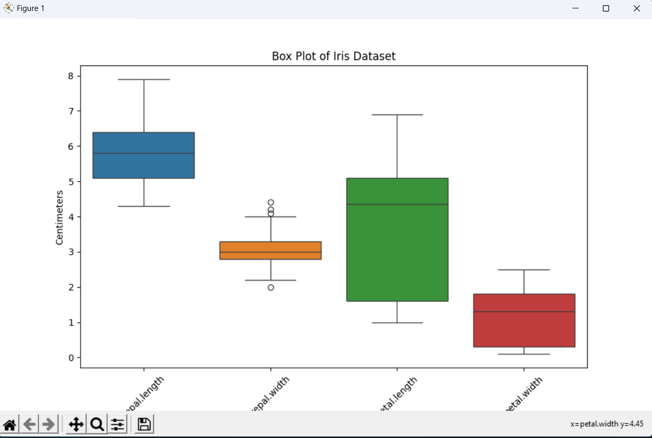3**Output:-**

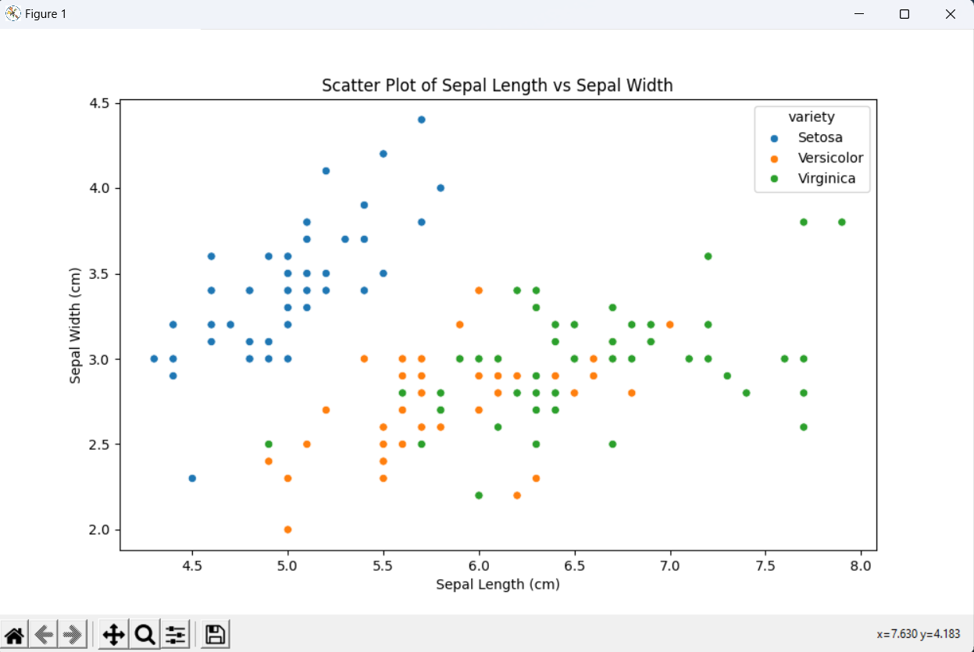

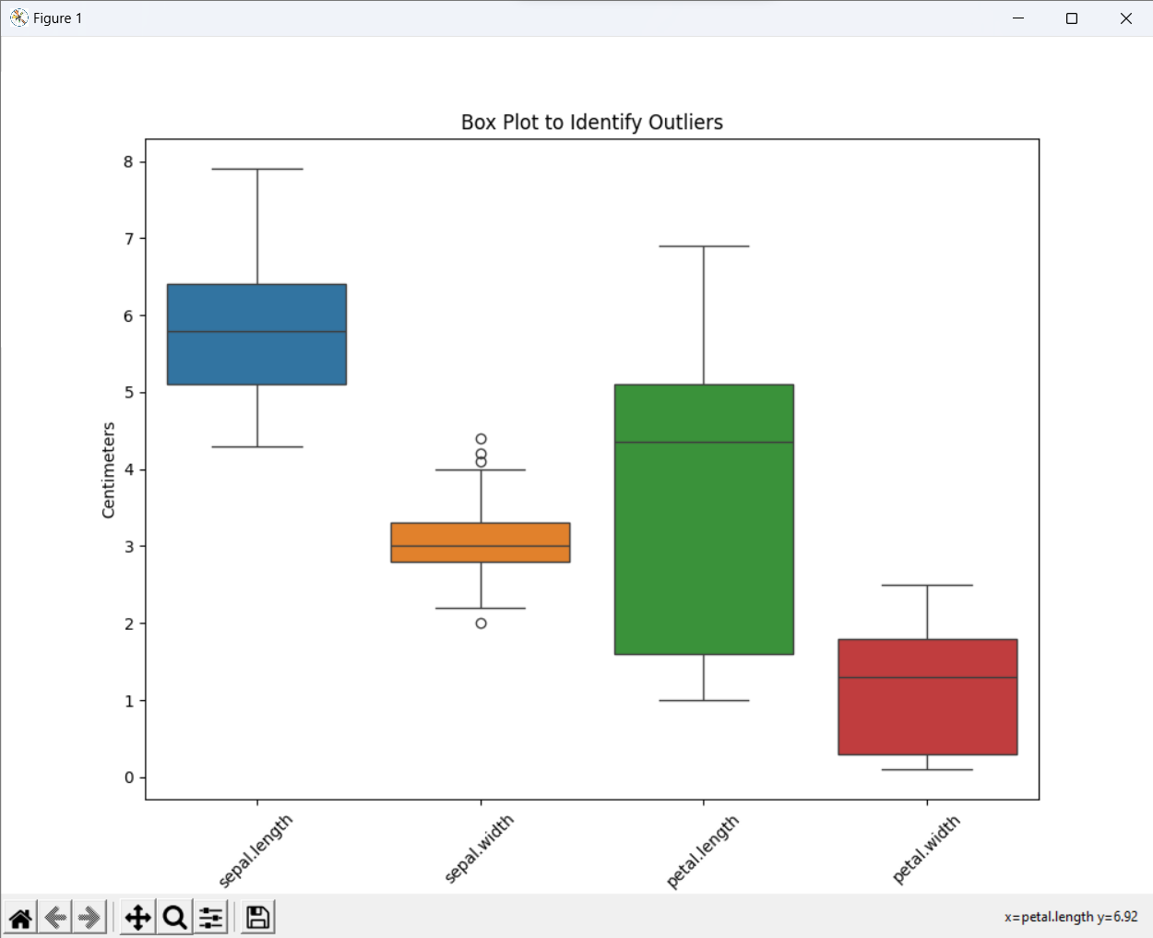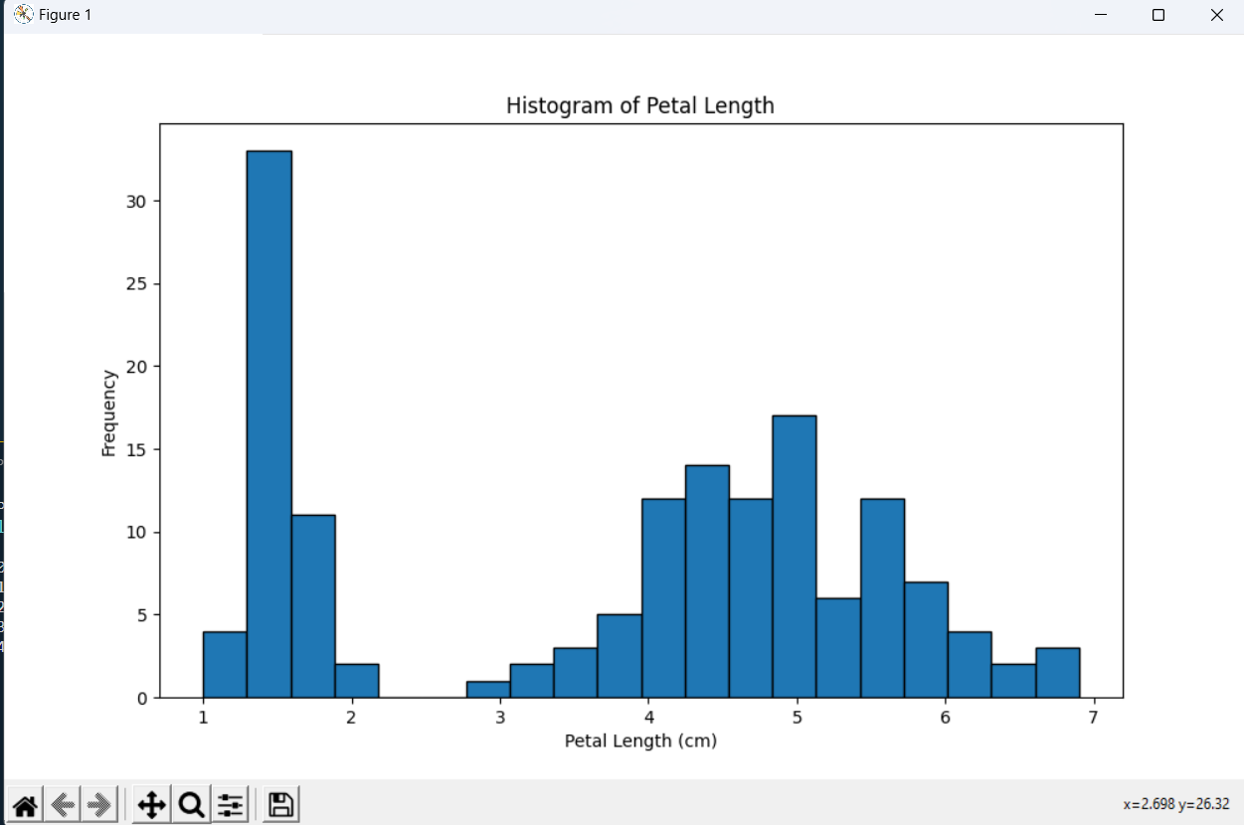

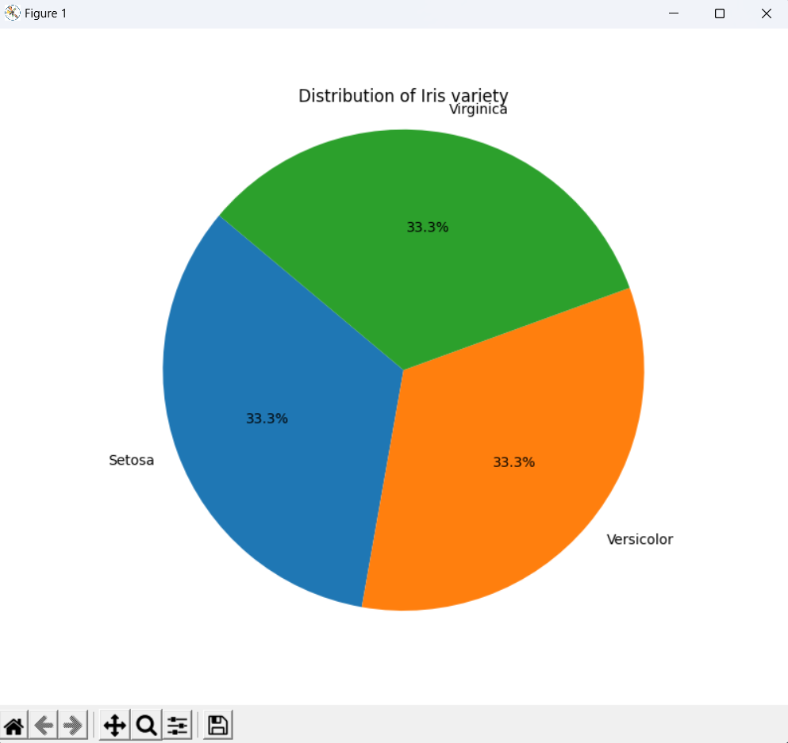

4**Code:-**

import pandas as pd

import matplotlib.pyplot as plt

import seaborn as sns

from scipy.stats import f_oneway

# Load the Iris dataset

iris_df = pd.read_csv("prac4/iris.csv")

# Display the first few rows of the dataset

print(iris_df.head())

# a. Correlation matrix (excluding the categorical column 'variety')

correlation_matrix = iris_df.drop('variety', axis=1).corr()

print("Correlation Matrix:")

print(correlation_matrix)

# b. Correlation plot

plt.figure(figsize=(10, 6))

sns.heatmap(correlation_matrix, annot=True, cmap="coolwarm", fmt=".2f", linewidths=0.5)

plt.title("Correlation Plot of Iris Dataset")

plt.show()

# c. Analysis of covariance (ANOVA)

# Perform ANOVA on petal lengths for each variety

setosa_petal_length = iris_df[iris_df['variety'] == 'Setosa']['petal.length']

versicolor_petal_length = iris_df[iris_df['variety'] == 'Versicolor']['petal.length']

virginica_petal_length = iris_df[iris_df['variety'] == 'Virginica']['petal.length']

# Perform ANOVA

anova_result = f_oneway(setosa_petal_length, versicolor_petal_length, virginica_petal_length)

print("ANOVA Result:")

print(anova_result)

4**Output:-**

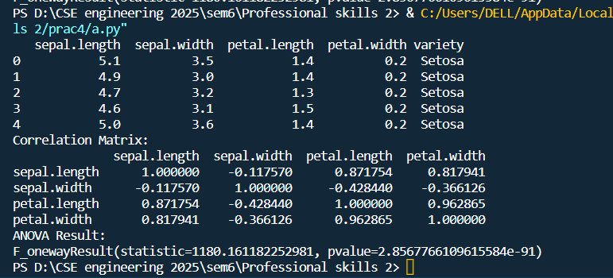

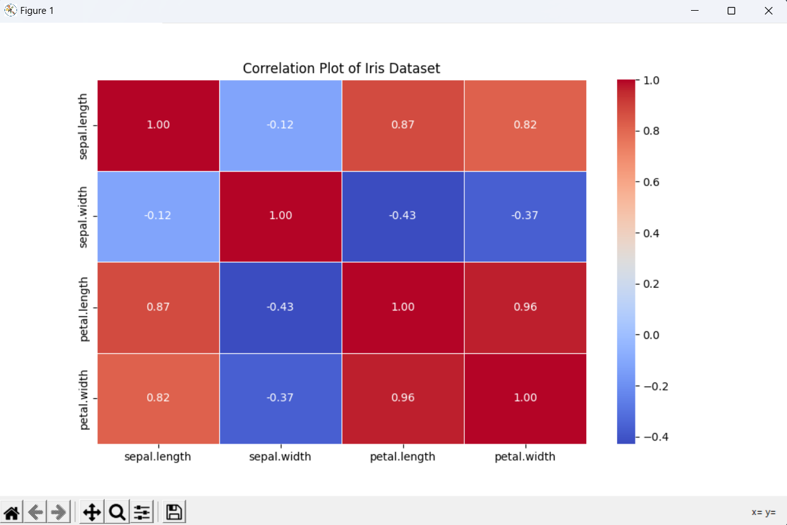

5**Code:-**

# Importing required libraries

import pandas as pd

from sklearn.model_selection import train_test_split

from sklearn.linear_model import LogisticRegression

from sklearn.metrics import accuracy_score

import statsmodels.api as sm

# Load your dataset

df = pd.read_csv('https://raw.githubusercontent.com/Opensourcefordatascience/Data-sets/master/admission.csv')

# Name your dataset

df.name = "Admissions_Dataset"

# Checking the first few rows of the dataset

print(df.head())

# Separating features and target variable

X = df[['gre', 'gpa', 'rank']]

y = df['admit']

# Adding constant term for logistic regression

X = sm.add_constant(X)

# Splitting the dataset into training and testing sets

X_train, X_test, y_train, y_test = train_test_split(X, y, test_size=0.2, random_state=42)

# Fitting logistic regression model

log_reg = sm.Logit(y_train, X_train)

result = log_reg.fit()

# Checking model summary

print(result.summary())

# Predicting on the test set

y_pred = result.predict(X_test)

# Converting probabilities to binary predictions

y_pred_binary = [1 if p >= 0.5 else 0 for p in y_pred]

# Calculating accuracy

accuracy = accuracy_score(y_test, y_pred_binary)

print("Accuracy of the logistic regression model:", accuracy)

5**Output:-**

